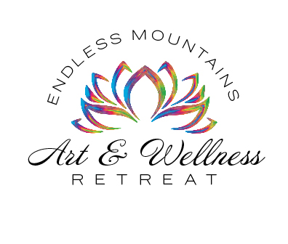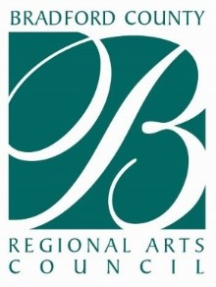

For more information or to register contact

Renae Chamberlain at Bradford County Regional Arts Council.

(570) 268-2787 or at ntpaie@bcrac.org

Weekend registration includes a healthy breakfast on Saturday and Sunday, lunch and dinner on Saturday, Friday and Saturday night activities, morning yoga or Zumba sessions, a clean eating and fitness workshop, and a nutritional supplement and essential oils workshop.

Limited on-site accommodations are available.

A variety of art workshops are also available on Saturday and Sunday at a fee set by the instructor.

Massages and facials will also be available for purchase Saturday afternoon.

Massages and facials by Bella Healing Arts will be available on Saturday by appointment.

A weekend to relax, rejuvenate, and have fun! Spend a weekend away in the beautiful Endless Mountains at the charming Inn on the Quarry Glen to treat your spirit, mind and body for better overall wellness. This is a time that we can come together to let go of the stress in our daily lives…connect and meet people who share similar values, be in the moment and let our creativity flow.

**The Inn on Quarry Glen**

**April 12th ~ 14th, 2019**

***“Art is a form of meditation…it’s all about healthy living and well-being.”***